**Assignment-4: Weather Data Analysis for analysing hot and cold days using MapReduce**

**Chaitanya Sai Nutakki  
AP21110010253**

**GETTING JAR FILE TO ROOT DIRECTORY**

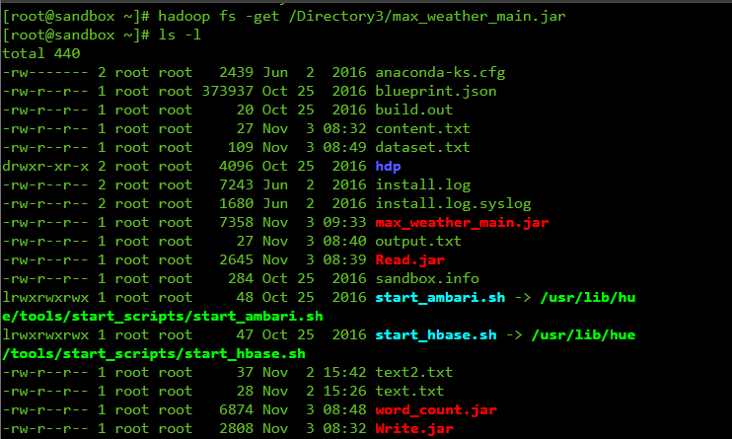

**RUNNING THE WEATHER JAR FILE**

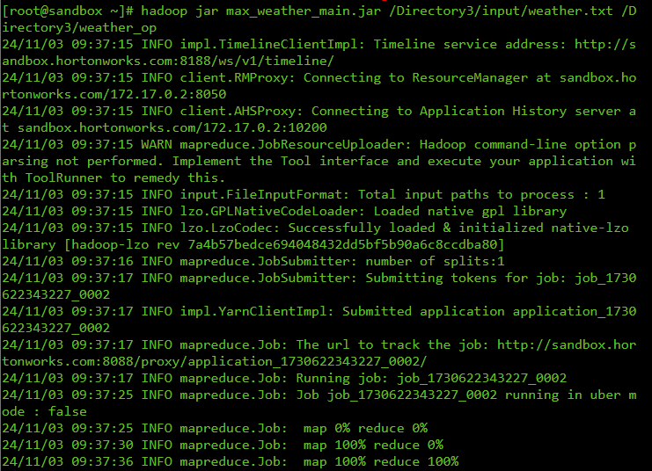

**FILE PREVIEW**

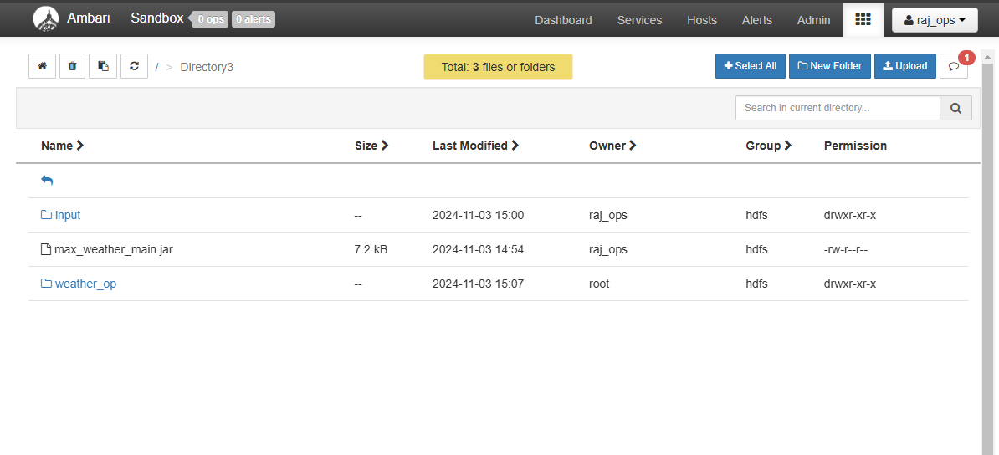

**OUTPUT TEXT FILE**

**COLD DAYS:**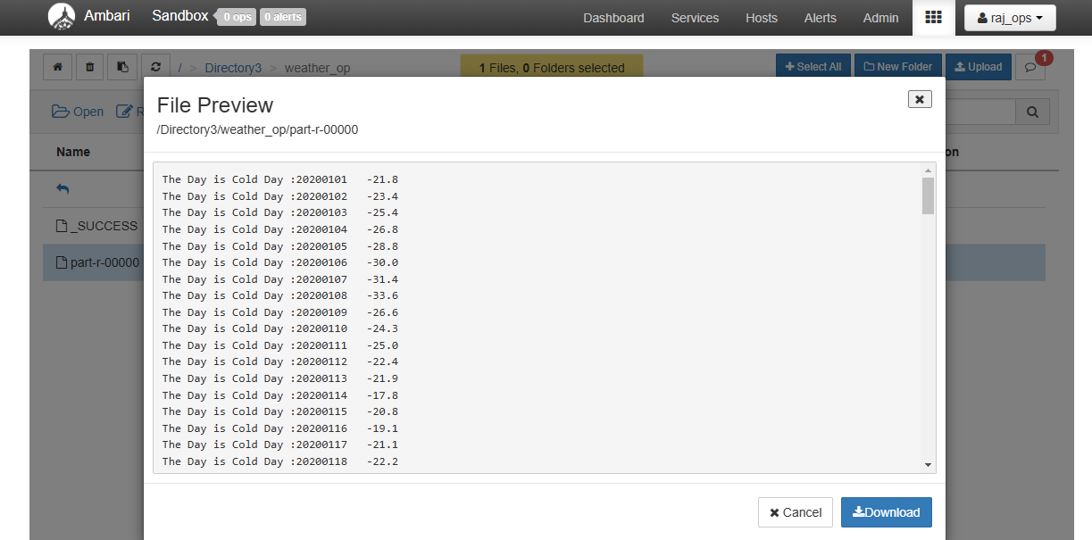

**HOT DAYS:**

